1. Project Proposal
1.1 Background the problem

More and more, audit firms are feeling the heat to handle projects, tasks, and reports with real transparency, accuracy, and speed. But most are still stuck using spreadsheets, email threads, and piles of paperwork. It's a mess: tracking who's doing what is nearly impossible, tasks get repeated by accident, nobody really knows who's responsible for what, and it always seems to take too long to get a report signed off. On top of all that, CEOs, managers, and auditors just aren't always on the same page, which drags out decisions and makes coordination harder than it should be.

If you walk into most firms, you'll see it in action - nobody can quite say which auditor is working on which job, or what stage a project is at, or even what's become of a report someone handed in last week. When everything's tracked by hand, leaving a reliable audit trail gets tricky, which isn't great for compliance either. Getting reports reviewed and approved is slow, too, just because no one has a single place to see and manage all that work. That means projects run longer than they should, and clients start to notice the difference.

What would actually help is an integrated Audit Firm Management System (AFMS). With the right system, everyone - whether they're the CEO, a manager, or an auditor - gets access that matches their role, so ownership is clear. Projects, tasks, and reports can finally be tracked as they should be. Instead of chasing paperwork, everything moves through a structured approval path, making it a lot easier to see what's going on at any moment. By taking audit operations fully digital, an AFMS cuts down on manual busywork, keeps people accountable, and gives managers the tools they need to make smarter decisions. It's the shift audit firms need if they want things to run smoother.

1.2 Selection of Process Model

Explanation of the Selected Process Model
Scrum is an iterative and incremental software development process model. In this model, the entire system is developed through a series of short development cycles known as Sprints. Each Sprint produces a working and testable version of the software. The duration of a Sprint is usually between one to four weeks.
The Scrum process focuses on continuous improvement, regular feedback, and close collaboration among team members and stakeholders. Instead of developing the entire system at once, Scrum allows the system to grow gradually by adding new features in each Sprint.
The Scrum process can be divided into three major phases:

Pre-Game Phase
In this phase, project planning and high-level system architecture are prepared. All system requirements are collected and listed in the Product Backlog, where they are prioritized according to business value.

Game (Development) Phase
This is the main development phase where the system is built through multiple Sprints. Each Sprint includes requirement analysis, design, implementation, and testing activities. At the end of every Sprint, a working increment of the system is delivered.

Post-Game Phase
In this phase, final integration, system testing, documentation, and release preparation are completed. The system is then made ready for deployment.

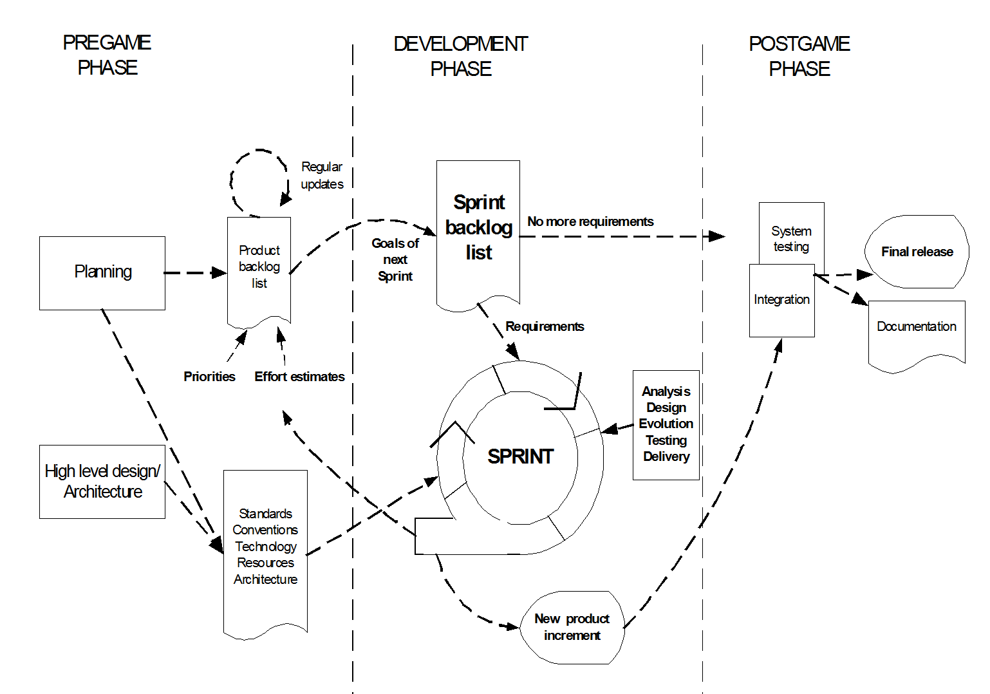

Product Backlog
↓
Sprint Planning
↓
Sprint (1–4 Weeks)
Design → Coding → Testing
↓
Working Software Increment
↓
Review & Feedback
↓
Next Sprint

Why Scrum Is Suitable for This Project
The Audit Firm Management System (AFMS) is a large and complex system involving multiple user roles such as CEO, Manager, and Auditor. The system includes several modules like project management, assignment handling, report submission, and approval mechanisms.
Scrum is suitable for this project because the system requirements may change during development. New features, report formats, or approval rules may be added based on user feedback. Scrum easily accommodates such changes through continuous backlog refinement.
Another reason for choosing Scrum is its incremental development approach. The AFMS can be developed module by module, allowing early delivery of core functionalities and gradual enhancement of the system.
Scrum also ensures frequent feedback from stakeholders. Regular reviews help identify issues early and reduce development risks. This improves software quality and ensures that the final system meets business needs.

Conclusion
Scrum is the most appropriate process model for the Audit Firm Management System because it supports iterative development, handles changing requirements efficiently, encourages stakeholder involvement, and reduces project risk through continuous feedback and incremental delivery.

